**VIETNAM NATIONAL UNIVERSITY, HO CHI MINH CITY**

**HO CHI MINH CITY UNIVERSITY OF TECHNOLOGY**

**OFFICE FOR INTERNATIONAL STUDY PROGRAMS**

**FACULTY OF TRANSPORTATION**

**Capstone Project**

**Modeling and simulation using Matlab/Simulink and its applications in the Electric**

**Power Steering system in VIOS.**

**Instructor: Ph.D Ngô Đắc Việt**

**Class:** TR4091 – CC01

**Name: Trịnh Tiến Long**

**Student ID: 1852047**

May 22th, 2023, Ho Chi Minh City, Vietnam

**🙦 Semester 222**

**VIETNAM NATIONAL UNIVERSITY OF HO CHI MINH CITY** **SOCIALIST REPUBLIC OF VIETNAM**

**HO CHI MINH UNIVERSITY OF TECHNOLOGY Independence – Freedom – Happiness**

Faculty of Transportation Engineering

Department of Automotive Engineering

**PROJECT MISSION**

1. **Student’s name**: Trịnh Tiến Long - Student ID: 1852047
2. **Major**: Automotive Engineering - Class: CC19OTO1
3. **Thesis title**: Modeling and simulation using Matlab/Simulink and its applications in the Electric Power Steering system in VIOS.
4. **Content:** Develop an Electric Power Steering model using Solidworks then applying to Simscape to determine the torque acting on the steering wheel for different steering angles and scenarios, such as following a predefined path or changing the speed of the test vehicle.
5. Product:
   * Full report.
   * Poster.
   * Simulink simulation.
6. **Assigned day**: ${23}^{th}$ December, 2022
7. **Finished day**: ${22}^{th }$ May, 2023

The content and requirements of the thesis is already approved by the Head of Department of Automotive Engineering.

HCMC, day….... month…… year 2023 HCMC, day… . month…… year 2023

**Head of Department** **Instructor**

**ACKNOWLEDGEMENT**

I would like to express my gratitude to the most important people in my academic journey.

Firstly, I want to thank my family for their unwavering support and encouragement throughout my studies. Their presence and guidance have been invaluable in shaping who I am today.

I am also grateful to the dedicated teachers at Bach Khoa University, especially those in the Department of Automotive Engineering, for sharing their knowledge and expertise with me. Their teachings over the past four years have equipped me with the skills and confidence to complete this thesis.

I would like to extend my gratitude to my mentors, PhD. Ngo Dac Viet and PhD. Tran Dang Long, for providing me with opportunities to learn, practice, and conduct field surveys. Their guidance and feedback have been instrumental in my academic growth.

Lastly, I want to thank the reviewer and department lecturers for their insightful feedback and suggestions, which have helped me refine my thesis. To my classmates in CC19OTO1, thank you for your camaraderie and support.

I wish my parents, family, lecturers in the Faculty of Transportation Engineering, as well as lecturers in the Department of Automotive Engineering, and all my friends good health and happiness.

**ABSTRACT**

This study presents a simulation of an Electric Power Steering (EPS) system using MATLAB Simulink and Simscape, based on the parameters of a Toyota VIOS passenger car with front-wheel drive.

The EPS model was built using SolidWorks and was designed to simulate the steering behavior of the VIOS under different driving conditions. The simulation results show that the EPS system provides the desired steering response for different driving conditions.

The study includes two parts: In the first part, the EPS system's responsiveness was evaluated by applying more torque on the steering wheel without help from motor. The simulation results showed that the steering system responded quickly to changes in steering input, providing accurate and responsive steering control.

In the second part, the study evaluated the torque changes needed to maintain a predefined driving situation. The simulation results showed that the EPS system provided the necessary torque changes to keep the VIOS on the desired path, demonstrating the system's effectiveness in maintaining vehicle stability.

The study also analyzed the effects of different parameters, such as the steering gear ratio and the controller gains, on the EPS system's performance. The simulation results showed that adjusting these parameters had a significant impact on the EPS system's performance, and that proper tuning of these parameters is essential for achieving optimal performance.

Overall, the simulation results demonstrate the effectiveness of the EPS system in providing responsive and accurate steering control for a Toyota VIOS passenger car with front-wheel drive. The study provides insights into the design and performance evaluation of EPS systems for this specific vehicle model, which could be useful for future research and development in this area.

**Table of Contents**

**Table of Figures**

Foreword

In Vietnam, under the continuous development of all aspects of social life, our country's economy is increasingly growing, with particular emphasis on industries that require a large amount of knowledge to meet the industrialization needs of the country. This requires technical fields to grasp new technologies and methods in order to keep up with the development of industries around the world. Among them, the automotive industry contributes significantly, and improving the performance of cars is of great concern. Electric power steering (EPS) contributes significantly to the ease of controlling a car in this system.

To understand the operation of this system, our group has rebuilt the steering system based on the VIOS car. One of the popular software applications for calculation and simulation is Matlab, with many advantages and a widely-used platform in calculation simulation.

After research, our group has decided to choose the topic "XXXX" to verify the accuracy of using Matlab/Simscape compared to classical calculation methods, and to evaluate the advantages and disadvantages of these methods. Essentially, the topic is the application of a new tool to solve an old problem, thereby verifying some of the surveyed parameters with the previous classical design process.

After studying and implementing the project, our group has preliminarily completed the project. However, due to our lack of experience, there may be some errors, so we hope to receive feedback from our respected teachers to improve the project.

We would like to thank Dr. Ngo Dac Viet and Dr. Tran Dang Long for their guidance, teaching, and useful advice during the completion of the project.

# I/ Introduction:

## **Objective:**

1. Electric Power Steering System

During the past ten years, EPS has been introduced in gradually increasing numbers. Although electric power steering system offer significant advantages over their hydraulic counterparts, electric motor technology and controls had not reached the point where they could be used in this application until just recently. Electrically assisted power steering is replacing the traditional hydraulic system where the pressure is provided via a pump driven by the vehicles engine. The hydraulic system is constantly running and by using the EPS the fuel consumption can be reduced. In electric and hybrid vehicles, the engine does not run continuously so electric power steering is the only possible solution.

Advantages:

* EPS is more energy-efficient than hydraulic power steering systems, resulting in improved fuel economy.
* EPS is quieter than hydraulic systems because it doesn't require a hydraulic pump.
* EPS offers better control and quicker response times, as the level of power assist can be adjusted based on the vehicle's speed and other factors.
* EPS can be integrated with other electronic safety features like lane departure warning and stability control.

Disadvantages:

* EPS systems can be more expensive to repair or replace than hydraulic systems.
* Some drivers may find that EPS lacks the same level of feedback and "feel" as hydraulic systems, leading to a less engaging driving experience.
* EPS systems can be heavier than hydraulic systems because they require an electric motor to provide the power assist.
* In the event of a power failure, EPS may become difficult or impossible to operate, whereas hydraulic systems would still function with greater effort required from the driver.

1. Matlab/Simulink

Simulink is a simulation and model-based design environment for dynamic and embedded systems, which are integrated with MATLAB. Simulink was developed by a computer software company MathWorks. Furthermore, it allows to incorporate MATLAB algorithms into models as well as export the simulation results into MATLAB for further analysis.

In Simulink, it is very straightforward to represent and then simulate a mathematical model representing a physical system. Models are represented graphically in Simulink as block diagrams. A wide array of blocks are available to the user in provided libraries for representing various phenomena and models in a range of formats. One of the primary advantages of employing Simulink (and simulation in general) for the analysis of dynamic systems is that it allows us to quickly analyze the response of complicated systems that may be prohibitively difficult to analyze analytically. Simulink is able to numerically approximate the solutions to mathematical models that we are unable to, or don't wish to, solve "by hand."

In general, the mathematical equations representing a given system that serve as the basis for a Simulink model can be derived from physical laws. The focus of this project is that we can get used to MATLAB Simulink with some examples and then apply that knowledge to simulate a simple Electric Power Steering system that usually been used in modern vehicles.

|  |  |  |  |
| --- | --- | --- | --- |
| **Tool** | **Concept** | **Application** | **Advantages** |
| Matlab | Software | Calculation and simulation | Widely-used platform, versatile, powerful numerical computation abilities, supports graphical user interface (GUI) for easy visualization and interaction with data, offers a large library of built-in functions and toolboxes for various applications, supports various file formats for importing/exporting data, can be integrated with other programming languages. |
| Simscape | Physical modeling language | Modeling physical systems | Allows for modeling and simulation of complex physical systems with ease, supports multi-domain modeling (e.g. electrical, mechanical, hydraulic), provides a library of pre-built components for easy modeling, offers a unified platform for modeling and simulation, can be integrated with Matlab for further analysis and visualization. |
| Simulink | Block diagram modeling | Dynamic system modeling and simulation | Provides a graphical user interface for modeling, simulating, and analyzing dynamic systems, supports a wide range of modeling and simulation tasks (e.g. continuous-time, discrete-time, hybrid systems, etc.), offers a large library of pre-built blocks for various applications, supports automatic code generation for embedded systems, provides real-time simulation capabilities, supports co-simulation with other software and hardware systems, offers various analysis and visualization tools for system analysis and optimization. |

1. **Scope of implementation:**

The scope of this thesis is to analyze the dynamic behavior of the Electric Power Steering (EPS) system in the VIOS model, by creating a simulation model in MATLAB/Simulink. The analysis will focus on the relation between the front axle and the steering system, and the results may not be applicable to other vehicle models.

1. **Working condition:**

## Constant steering angle, constant speed: In this scenario, the VIOS vehicle will be driven at a constant speed on a predetermined road, while the steering angle is kept constant. The purpose of this scenario is to evaluate the performance of the electric power steering system in maintaining the steering angle at a constant value, given the driving conditions and the characteristics of the road.

## Following a predefined road: In this scenario, the VIOS vehicle will be driven on a predefined road with a set of steering commands to follow the road. The steering commands will be generated based on the road curvature and the desired speed. The purpose of this scenario is to evaluate the performance of the electric power steering system in tracking the desired steering commands and following the road accurately, given the driving conditions and the characteristics of the road.

## **Technical requirement:**

Correct technical specifications are ensured to guarantee that the system operates within specified parameters with low margin of error.

1. **Limitation**

The limitation of this study is that the parameters based on the VIOS vehicle were measured at an automotive workshop at the University of Technology, so they may not be entirely accurate.

## **Conditions and Requirements for Building Simulation Models, Conditions for Applying Matlab Simulink/Simscape Software**

|  |  |
| --- | --- |
| **Conditions for building simulation models and applying Matlab Simulink - Simscape.** | **Building a mechanism model that closely matches reality on Solidworks and linking it to Matlab.** |
|  |  |

# II/ Theoretical basics:

* + - 1. **Diagram, schematic

         Description automatically generatedMass damper theory:**

Figure 2: Mass - damper model

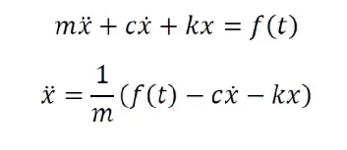The Mass-Spring-Damper model is one of the most common models used by engineers to model kinematic systems. From human tissue to bridges, this straightforward model features three mechanisms and can be summarized as the following second-order differential equation:

Here x represents the displacement of the object with mass m away from its resting position. The mass is subject to some spring force characterized by spring constant k and a damping force that resists change in motion with damping coefficient c. The function g here can be thought of as some input to the system that could depend on position, velocity, or time. For this example, we can vary f(t) as an input.

* + - 1. **Some simple mechanical model**

## Rotational mechanical system

Figure 3: Rotational mechanical system

For the system shown in Fig 3, we can write equations for disk 1 and disk 2:

This example can be used to explain the equation for torsion bar’s parameter (Ks and Bs in the next part).

1. Mechanical system with gear train

For the system shown in Fig 4, we can write equations for the system:

Base on these simple mechanical model, we can apply to find out equations for EPS system in the next part.

Figure 4: Mechanical system with gear train

* + - 1. **Electric Power Steering Dynamic equations:**

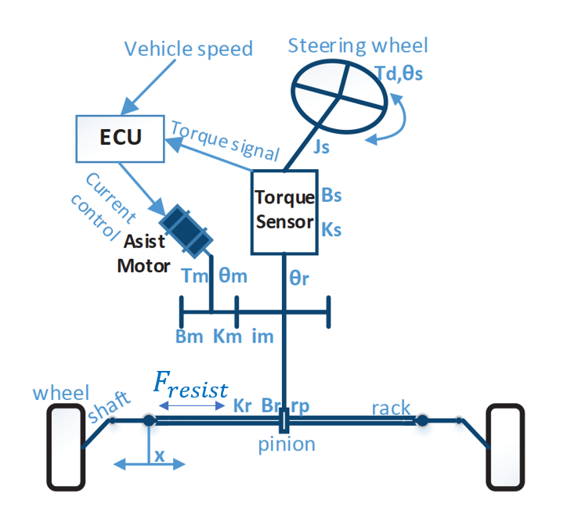

Figure 5: The overall Electric Power Steering dynamic factors

**Figure 5** illustrates the physical structure of a steering system. The structure components are a column type steering system which include the steering wheel, steering column, the rack and the pinion mechanism. The assistance motor is a permanent magnet synchronous motor, connected to the steering shaft through gears and provides the assisting torque needed by the driver to steer the vehicle. The input torque from the steering wheel is measured by a torque sensor mounted on the steering column and connected to the electronic control unit. The assistance torque produced by the motor act on the wheel via rack and pinion system. Different amount of assistance torque is applied depends on the driving conditions, which is realized with a specific control logic implemented in the ECU.

Using Newton's law and neglecting no necessary factors the equations of EPS can be derived:

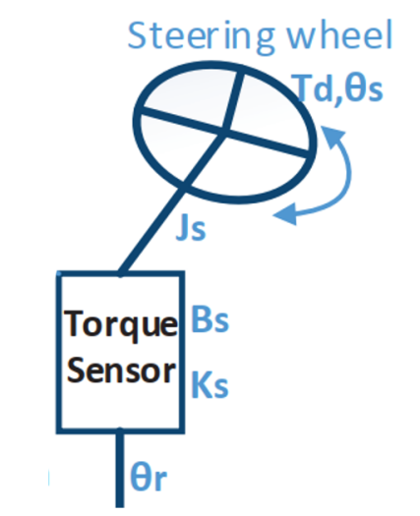

Figure 6: Overall structure of the steering input

* The dynamic equations from the steering wheel to steering column:

$$J_{s}×\frac{{d^{2}}_{θ_{s}}}{dt^{2}}=T_{d}-K_{s}\left(θ_{s}-θ_{r}\right)-B_{s}×\frac{d_{θ_{s}}}{dt^{2}}$$

While:

$J_{s}:$ Inertia of steering wheel and steering column (kg. $m^{2})$

$B_{s}:$ Viscous damping coefficient of steering column (deboost of steering column) (Nm. ${rad}^{-1})$

$K_{s}:$ Rigidity of torsional bar (Nm. ${rad}^{-1}$)

$θ_{s}:$ Turn angle of steering wheel (rad)

$θ_{r}:$ Turn angle of output steering axle (rad)

$T_{d}:$ Input torque of steering wheel (N.m)

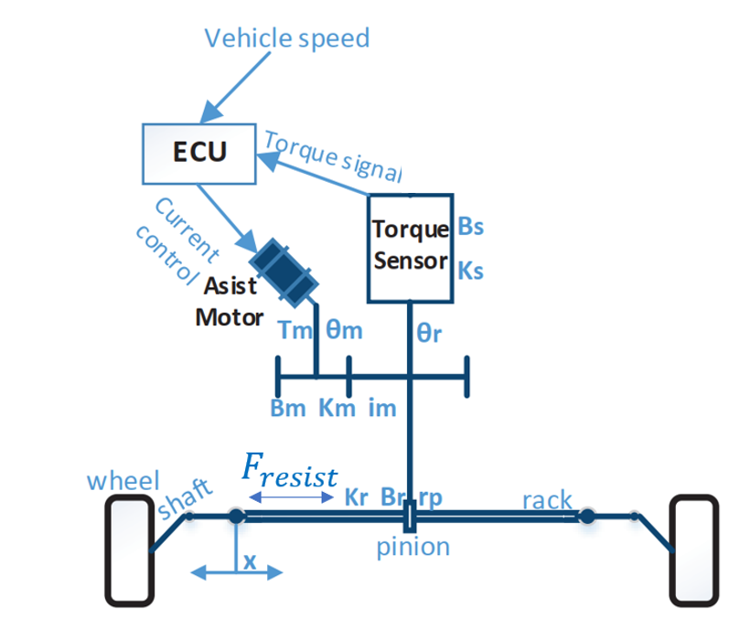

Figure 7: Overall Rack and Pinion Dynamics

* Finally, rack and pinion section is illustrated in Figure 7 and governed by the equation:

$$m×\frac{d^{2}x}{dt^{2}}=\frac{1}{r_{p}}\left[K_{s}\left(θ_{s}-θ_{r}\right)\right]-B_{r}×\frac{d_{x}}{dt}-K_{r}×x$$

While:

m: mass of the pinion and rack (kg)

$r_{p}:$ pinion radius ($m)$

$B_{r}:$ Viscous damping coefficient of rack and pinion (deboost of the rack and pinion) (Nm. ${rad}^{-1})$

$θ_{r}:$ Turn angle of output steering axle (rad)

$θ_{s}:$ Turn angle of steering wheel (rad)

$K_{s}:$ Rigidity of torsional bar (Nm. ${rad}^{-1}$)

We can see in above equation we have the resist force apply on the rack. This force that resists the motion of the rack when the driver is steering

# III. MATLAB/SIMULINK SIMULATION

**Mass** **– damper system**

Figure 8: Parameter of mass-damper system

### 1.1) Simulink block diagram

Figure 9: Mass-damper block diagram

### 1.2) Simulation result and discussion

* The position and velocity of the spring-damper system are generated by solving the developed transfer function using MATLAB. The displacement graph is shown in Fig 10b while the velocity graph is shown in Fig 10a.
* For the given parameters of the system, the position vs. time response in MATLAB gives the maximum value equal to 1.961 m. Similarly, the maximum velocity is found to be 9.761 m/s.
* Simulink model uses the solver ode45 for solving the differential equation for the spring-mass-damper system.

Figure 10a-b: Simulation result

1. **EPS system**

### 2.1) Simulink block diagram

|  |  |  |
| --- | --- | --- |
| Symbols | Value | Name |
| $$J_{s}$$ | 0.0012 [kg $m^{2}$] | Inertia of steering wheel and steering column |
| $$B_{s}$$ | 0.26 [Nm ${rad}^{-1}$] | Viscous damping coefficient of steering column |
| $$K_{s}$$ | 115 [Nm ${rad}^{-1}$] | Rigidity of torsional bar |
| $$θ_{s}$$ | [Rad] | Turn angle of steering wheel |
| $$θ_{r}$$ | [Rad] | Turn angle of output steering axle |
| $$T_{d}$$ | [Nm] | Input torque of steering wheel |
| $$T_{m}$$ | [Nm] | Output torque of the motor |
| $$K_{m}$$ | 125 [Nm ${rad}^{-1}]$ | Rigidity of the motor and reducer |
| $$B_{m}$$ | [Nm ${rad}^{-1}]$ | Viscous damping coefficient of the motor |
| $$i_{m}$$ | 7.225 | Reduction ratio of reducer |
| $$θ_{m}$$ | [Rad] | Turn angle of motor |
| $$K_{r}$$ | 91064 [N $m^{-1}$] | Linear rigidity |
| $$B_{r}$$ | 653.203 [Nm ${rad}^{-1}]$ | Viscous damping coefficient of rack and pinion |
| $$r_{p}$$ | 0.007783 [m] | Pinion radius |
| x | m | Rack displacement |
| $$m_{r}$$ | 32 [kG] | Mass of the rack and pinion system |
| m | [kG] | Mass of the vehicle |
| $$l$$ | [m] | Wheelbase |
| $$b$$ | 1.684 [m] | Track width |
| g | 9.8 [m $s^{-2}]$ | Gravitational acceleration |
| $$C_{f}$$ | 70000 [N ${rad}^{-1}$] | Cornering stiffness of front axle |
| $$l_{1}$$ | 1.32484 [m] | Distance from front axle to center of vehicle |
| $$l_{2}$$ | 1.532 [m] | Distance from rear axle to center of vehicle |
| $$L_{arm}$$ | 0.08 [m] | Disturnbance force moment arm |

Table 1: Electric Power Steering Parameters

Figure 11: EPS simulation

### 2.2) Block function

|  |  |
| --- | --- |
| **Block in Simulink** |  |
| **Function that block represent for** | $$J_{s}×\frac{{d^{2}}_{θ_{s}}}{dt^{2}}=T_{d}-K_{s}\left(θ_{s}-θ_{r}\right)-B_{s}×\frac{d_{θ_{s}}}{dt^{2}}$$ |

Table 2: Block for first equation

|  |  |
| --- | --- |
| **Block in Simulink** |  |
| **Function that block represent for** | $$m×\frac{d^{2}x}{dt^{2}}=\frac{1}{r_{p}}\left[K_{s}\left(θ_{s}-θ_{r}\right)\right]-B_{r}×\frac{d_{x}}{dt}-K_{r}×x$$ |

Table 3: Block for second equation

### 2.3) Simulation result and discussion

Figure 12: Result of simulation

The inputs to this system are the torque generated by the driver. Since we present a model of the power steering system, details of the tire dynamics are neglected. The outputs of the mechanical subsystem are the displacement of the rack, X, and the rotational displacement of the steering column θS.

As we can see from Fig 12, with θS changed from 0 to nearly 1 rad, x jumped to approximately 7x10-3 m. Input touque at 3s is 5Nm.

Figure 13: Second result of simulation

In second result, the input in steering wheel angle is generated in a sine shape which goes from -300 degrees to 300 degrees. As we can see, the rack displacement also changed in sine shape also, going from -0.04m from center to 0.04m (positive direction goes from left to right)

Figure 14: Third result of simulation

Same configuration with second results but we increase frequency of changing in steering wheel angle by 2 (so the period will be decreased by 2). The result is the same as we expected: rack displacement x also rise the speed of changing by +2.

# V. CONCLUSION AND FUTURE WORK

Basis theory about modeling mechanical system and Matlab/Simulink are included.

Simulate a mass – damper system in order to learn how Matlab/Simulink work has been done in this project also.

Moreover, a dynamic model of a power steering system is developed by applying above knowledge. The model can be used for performance evaluation and can be easily adapted to fit in a larger vehicle handling model. It can also be used for the design of other power steering systems, where it allows the designer to test changes in dynamic conditions. Other variations, such as pinion radius, stiffness of the torsion bar or piston area can be made as well, and the results tested in the same manner. The simulation results agree to a great extent with the real test results. Although how good that is, this project is made only for education purposes and has limitation shown in the beginning.

After having simulation about EPS system, we can easily obtain the relevant between steering wheel and rack displacement. In the future, this project can contain the support from motor, also can deal with load which are restrain, aligning moment acting from road back to the system. We also include the effect of camber, caster and kingpin angle to EPS system.

# VII. REFERENCE

1. Cossalter, V. (2010). *Motorcycle Dynamics*. Lulu.
2. Genta. (2020). *The automotive chassis*. Springer International Publishing.
3. Hiremath, R. R., & Isha, T. B. (2019). Modelling and simulation of electric power steering system using permanent magnet synchronous motor. *IOP Conference Series: Materials Science and Engineering*, *561*(1), 012124. https://doi.org/10.1088/1757-899x/561/1/012124
4. Jazar, R. N. (2008). *Vehicle dynamics: Theory and applications*. Springer.
5. Nasir, M. Z., Dwijotomo, A., Abdullah, M. A., Hassan, M. Z., & Hudha, K. (2012). Hardware-in-the-loop simulation for automatic rack and pinion steering system. *Applied Mechanics and Materials*, *229-231*, 2135–2139. https://doi.org/10.4028/www.scientific.net/amm.229-231.2135
6. Nemes, R.-O., Ruba, M., & Martis, C. (2018). Integration of real-time electric power steering system MATLAB/Simulink model into National Instruments Veristand Environment. *2018 IEEE 18th International Power Electronics and Motion Control Conference (PEMC)*. https://doi.org/10.1109/epepemc.2018.8521888
7. Pacejka, H. B. (2002). *Tyres and vehicle dynamics*. Butterworth-Heinemann.
8. Qun, Z., & Juhua, H. (2009). Modeling and simulation of the Electric Power Steering System. *2009 Pacific-Asia Conference on Circuits, Communications and Systems*. https://doi.org/10.1109/paccs.2009.67
9. Ingale, A. (no date) “Modeling Mass-Spring-Damper System using Simscape,” *Journal of Engineering Research and Application* [Preprint]. Available at: https://doi.org/10.9790/9622-0801033033.
10. Sh., A., H., E. and A., E.-H. (2006) “Side-stick control of power rack and pinion steering system,” *The International Conference on Applied Mechanics and Mechanical Engineering*, 12(12), pp. 383–396. Available at: https://doi.org/10.21608/amme.2006.41261.